## Problem 4 – Unresponsive Site

You are given an unresponsive Web site (**HTML** + **CSS** + images). The website is 960px wide and has whitespaces from the left and the right side (see Figure 1). Your task is to **make the site responsive**. The site layout should change according to the browser viewport / screen size.

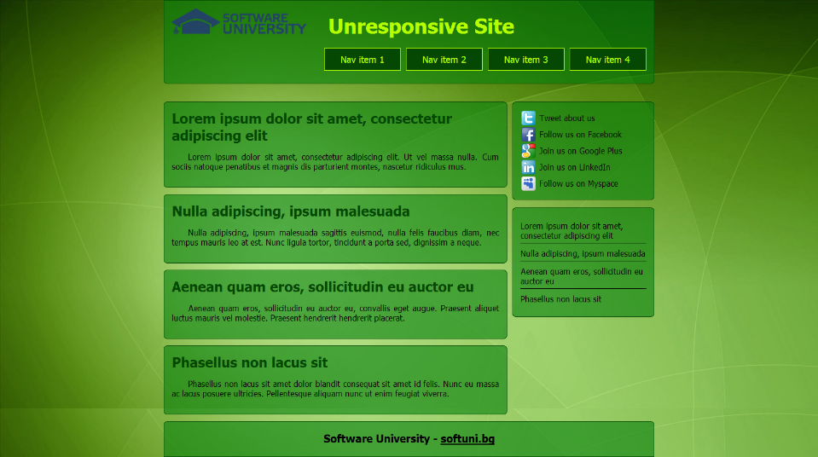 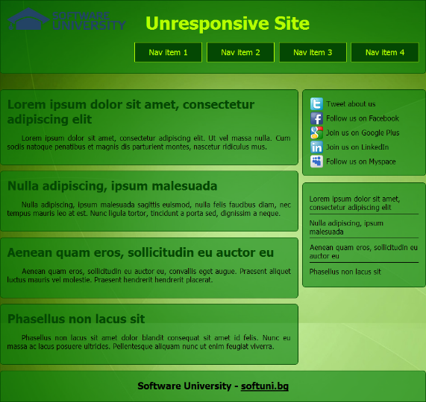

Figure 2

Figure 1

1. From **780px to 960px** – whitespaces disappear, the articles and sidebars scale proportionally with the browser window (see Figure 2).
2. From **640px to 780px** – the menu becomes centered and the menu items are distributed evenly in the entire header (see Figure 3).

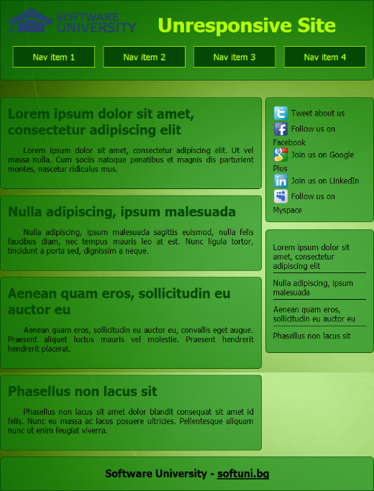 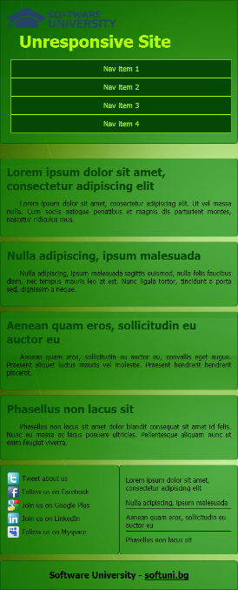 

Figure 5

Figure 4

Figure 3

1. From **480px to 640px** – the menu changes again. The sidebars move to the bottom of the page side by side. The header falls under the logo and they are centered (Figure 4).
2. **Under 480px** – the second sidebar falls after the first one (Figure 5).

### Input

You are given the unresponsive site as HTML + CSS + images.

### Output

The output should be valid HTML5 + CSS3 + images that implement the above responsive site.

### Constraints

* You are free to change the HTML and CSS, as well as use external frameworks like Bootstrap.
* Pixel-perfect implementation is not required.